**Installation of Node js**

**Pre-requisite:**

Minimum windows /mac configuration

Website: https://nodejs.org/en/download

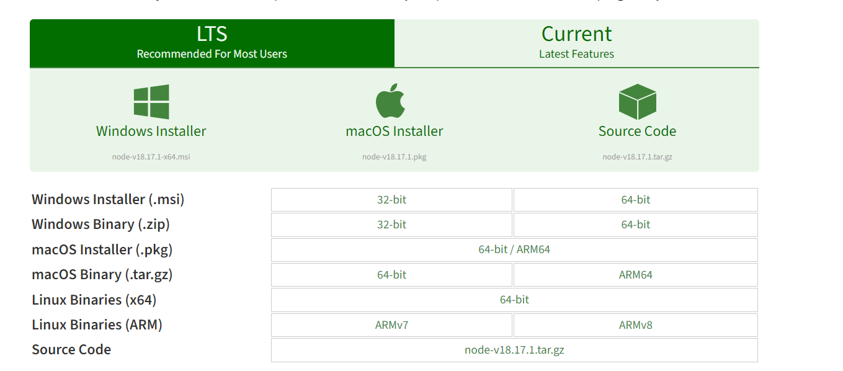

1. Depending on the OS version download the version from the LTS (Latest stable version) tab
2. Current tab means the latest version but not a stable one will have experimental features and other changes which are not recommended for most system.

**For Windows Machine:**

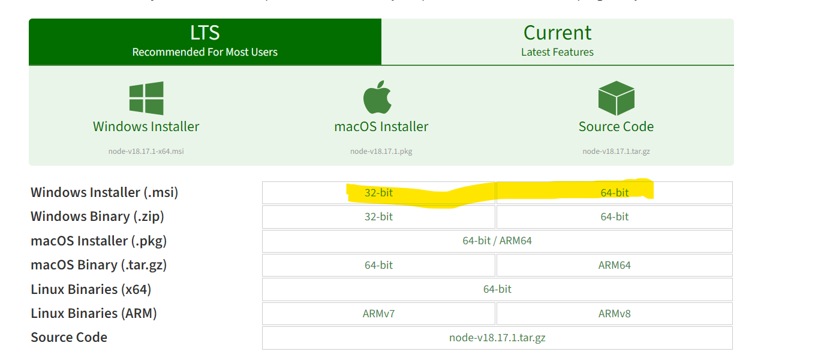

1. If holding a windows machine/laptop as highlighted use either one of the installation depending on the machine whether its 32 or 64 bit
2. How to identify 32 or 64 bit machine 🡪 please refer the screenshot
3. Right click on the My PC 🡪 Properties 🡪System🡪 About as highlighted below screenshot in yellow

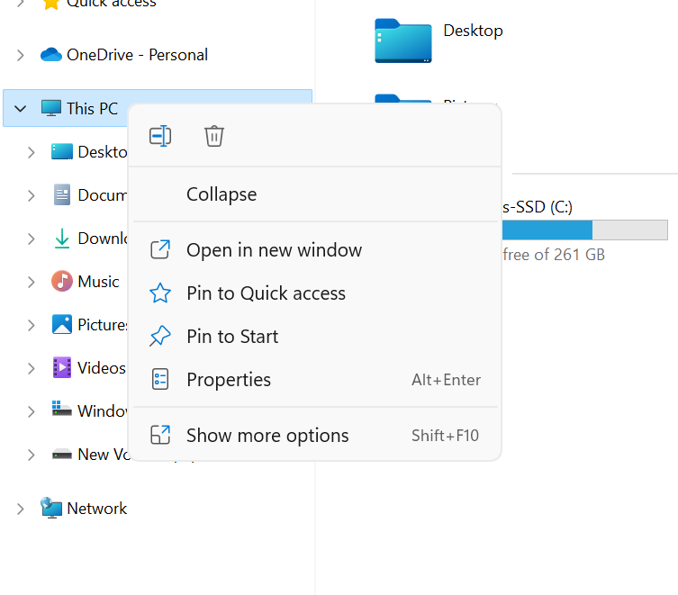

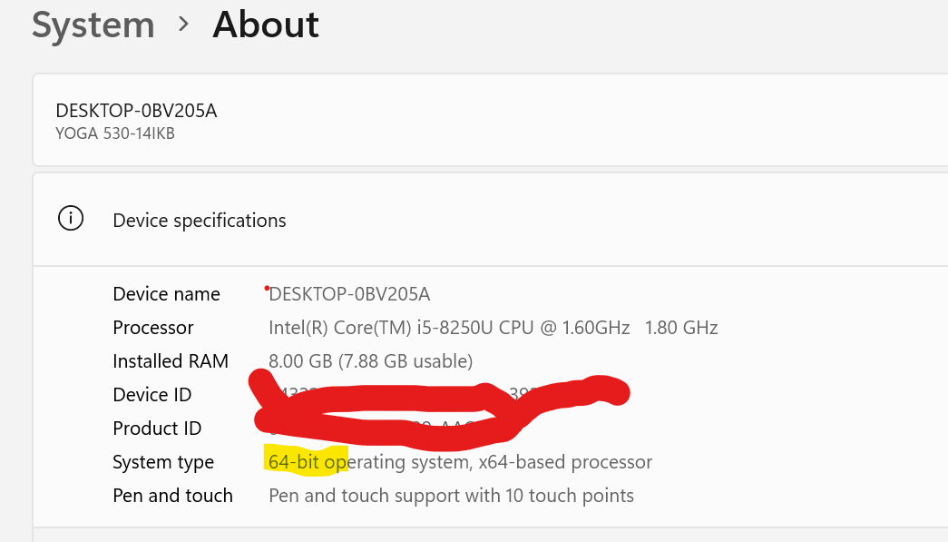

**For Mac:**

1. As highlighted below use the version to install
2. Just run the .pkg file
3. Or Mac would ask you to drag and drop the .pkg file in application and it will be installed

**How to Check the node version:**

1. For Mac use terminal and Windows use command prompt
2. Use the commands as below
   1. node --version 🡪 this will give the node version.
   2. npm -- version 🡪 this will give the node package manager version(npm)
3. NPM is nothing but which is prebuilt inside the nodejs**A black background with white text

   Description automatically generated**

**How to Set Environment Variable for node in Windows?**

1. We need to navigate to the path where the nom is installed as below sample in my machine
   1. C:\Users\Lenovo\AppData\Roaming\npm
2. Then we need to search for the “Edit environmental variable” in the laptop /desktop

1. If you have access to System Variable use it else go for user variable
2. Go to the path as highlighted and click Edit and use the path of npm identified in **step1.**